***Finite Math 106***

***Section 6382***

***Summer 2016***

***Quiz #3***

**Please answer all questions.  The maximum score for each question is posted at the beginning of the question, and the maximum score for the quiz is 100 points.  Make sure your answers are as complete as possible and show your work/argument.  In particular, when there are calculations involved, you should show how you come up with your answers with necessary tables, if applicable.  Answers that come straight from program software packages will not be accepted.  The quiz is due by 11:59 pm, Sunday, June 12, 2016, Eastern Daylight Saving Time.**

***IMPORTANT:*** Per the direction of the Dean's Office, you are requested to include a brief note at the beginning of your submitted quiz, confirming that your work is your own.

    By typing my signature below, I pledge that this is my own work done in accordance with the UMUC [Policy 150.25 - Academic Dishonesty and Plagiarism](http://www.umuc.edu/policies/academicpolicies/aa15025.cfm) (<http://www.umuc.edu/policies/academicpolicies/aa15025.cfm>) on academic dishonesty and plagiarism. I have not received or given any unauthorized assistance on this assignment/examination.

_________________________

Electronic Signature

Your submitted quiz will be accepted ***only if*** you have included this statement.

1. (10 points) Write the augmented matrix for the following linear equations. (Do not solve.)
2. 10x – 7y = 15

-5x + y = -10

(b) 2x + 3y – 5z = 6

x - y + 3z = -4

-x - 3y + 4z = 7

1. (10 points) Given the following augmented matrix

$\begin{matrix}1 & 1 & | 4 \\ 1 & -1 & | -2\end{matrix}$

1. Solve the augmented matrix system by Gaussian elimination. Be sure to annotate each of your steps.
2. Write the corresponding linear equations in x and y.
3. Plot the corresponding linear equations on a graph.

You can use the line graphing utility <https://www.desmos.com/calculator>

1. Does the intersection point of the two equations match the points you got in (a)? (yes or no)
2. (10 points) You have been given a total of $500 for your birthday from your grandparents. The rich set of grandparents (x) gave you 3 times as much as the poor set of grandparents (y).
3. Write two equations in x and y which expresses the above two statements mathematically.
4. Plot these two equations on a graph.
5. What is the intersection point of the two equations from your graph?
6. Write the augmented matrix for this set of equations.
7. Solve for the solution of these two equations using algebra.
8. (10 points) Plot the following inequalities on a graph. Shade in the feasibility region. You can put all of the equations on the same graph.
9. y <= -3
10. x > 5
11. x + 2y > 6
12. (15 points) Plot the following 2 equations on the same graph.

x + 2y <= 12

3x + y <= 11

1. Shade in the feasibility region of overlap of the equations with the additional conditions x >= 0, and y >= 0.
2. What are the coordinates of the 4 corner points of the overlap region?
3. What is the augmented matrix of the two equations in x and y?
4. Solve for the intersection point of the two equations using Gaussian elimination. Annotate each step you make.
5. Does you intersection point match one of the corner points in (b)? (yes or no)
6. (15 points) Given the graph below.

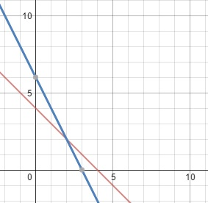

1. What is the equation of the red line in y-intercept form?
2. What is the equation of the blue line in y-intercept form?
3. Instead of y = for the red line, let it be y >=.

Instead of y = for the blue line, let it be y <=.

Also let x >=0 and y >= 0.

Shade in the feasibility region for the 4 conditions.

1. What are the coordinates of the corner points to the region you shaded in (c)?
2. (15 points) Given the graph below.

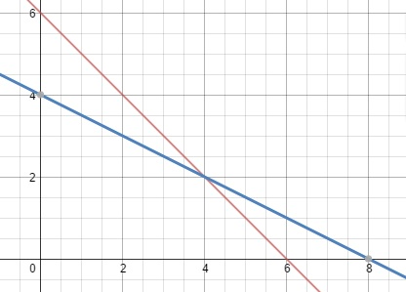

1. What is the equation of the blue line in y-intercept form?
2. What is the equation of the red line in y -intercept form?
3. Also, let x >= 0 and y >= 0. If the feasibility region is to be the upper right hand side of the graph, what does the equal sign (=) in the blue line equation have to be changed to? ( >= or <=)
4. What does the equal sign (=) in the red line equation have to be changed to? (>= or <=)
5. What are the coordinates of the corner points for the upper right hand side region?
6. (15 points) At a certain gas station, a total of 500 gallons of gas was sold on a particular day. Regular gas (x) sells for $2.25 per gallon. Premium gas (y) sells for $3.00 per gallon. The total gas receipts for the day was $1,233.75.
7. Write an equation in x and y for the number of gallons of gas sold.
8. Write an equation in x and y for the amount of money received.
9. Write the augmented matrix for (a) and (b).
10. Solve for x and y using the augmented equation and Gaussian elimination. Annotate each step you take to get to your answer.
11. Verify that your answer is correct by putting x and y into the equations you derived in (a) and (b).